Rapidly changing fields and electromagnetic waves

The concept of the displacement current
Let us regard the circuit in Figure a) below (Maxwell’s problem). The circuit contains a current generator (a device producing constant current I independent of the voltage) and a thick conductor with cross-section A which is cut into two pieces as the Figure shows.

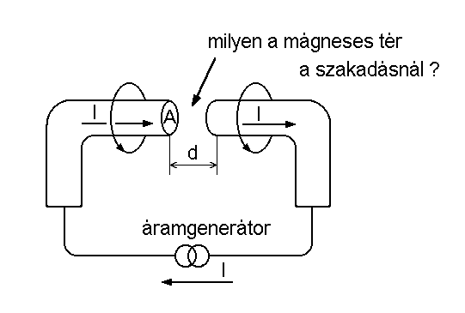 | 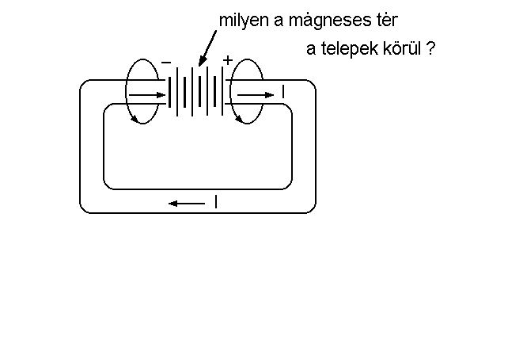
a) | b)
Maxwell’s problem | Ampére’s problem

The cut surfaces be close to each other separated by a gap of length d. The gap be filled with an insulator of permittivity ε . This way the cut surfaces form a parallel plate condenser with a capacity C:
$$C=\frac{ε A}{d} ,$$
The charge Q on the capacitor is increasing continuously due current I of the current generator:
$$\frac{\text{dQ}}{\text{dt}}=I ,$$

and a steady current can flow in the circuit in spite of the gap as the current charges the capacitor whose voltage increases continuously. While the electric field rises continuously in the gap there is no current in this space because the gap is filled with an insulator. (In an insulator there are no charge carriers and without that no conduction current is possible.)
Here we can ask an interesting question about the magnetic field. We know that the conduction current generates a circular magnetic field according to Ampére’s law. But what happens with the magnetic field in the gap? This question was asked first by Scottish physicist named James Clark Maxwell. His answer to this problem made the theory of electromagnetism complete after the discoveries of Oersted, Ampére, and Faraday.
Before discussing the answer of Maxwell, however, let us study a similar problem of Ampére about half a century earlier. Ampére, as we know studied the magnetic field of the electric current. A usual electric circuit consists of a battery (it was called as Voltaic cell in that time) and a metal wire conducting the current between the terminals of the battery. Oersted found a magnetic field around a platinum wire when an electric current was flowing in it. Ampére wanted to know (see Figure b) above) whether there is a magnetic field around the battery as well when a current is flowing through that. He could prove experimentally that the magnetic field depends on only the current but it does not depend whether it flows in a metallic conductor or in a battery. Now we would say that the magnetic field of the current does not depend on the type of the charge carriers whether they are electrons or ions. Thus the magnetic field is continuous and it is not interrupted or weakened around the batteries.
Maxwell’s gave a similar answer to his problem: the magnetic field should be continuous and should not be interrupted or weakened in the neighborhood of the gap capacitor. Thus something in the gap should generate a magnetic field like a current but without the movement of any charge carriers. Now we have to find a physical quantity which plays the same role in the insulator like the electric current in the conductor.
In the gap capacitor there is no traditional current but the time derivative of the D field multiplied by the cross-section A should be equal to the current I flowing in the conducting wires:

$$I=\frac{\text{dQ}}{\text{dt}}=\frac{d}{\text{dt}}\left(C U\right)=\frac{d}{\text{dt}}\left(\frac{ε A}{d} U\right)=A \frac{d}{\text{dt}}\left(ε \frac{U}{d}\right)=A \frac{d}{\text{dt}}\left(ε E\right)=A \frac{\text{dD}}{\text{dt}} ,$$

Thus if the magnetic field in the gap is the same like in other places of the circuit then product A⋅dD/dt should generate the same magnetic field like I. Thus A⋅dD/dt can be regarded as a current from the point of the magnetic field: this is the so called displacement current:
$$I_{\text{ELTOLÁSI}}=A \overset{}{D} \text{.}$$

and the density of the displacement current is

$$j_{\text{ELTOLÁSI}}=\overset{}{D} \text{.}$$

Naturally the displacement current can be regarded as a current only from the point of the magnetic field. If we define electric current as the movement of charge carriers then the displacement current is not a „real” current. If we define the electric current, however, as something which generates magnetic field around itself, then the displacement current is also a „real” current.

The above example was special because we assumed only conduction current in the conductor and only displacement current in the insulator. In general in both medium both current may appear and when they are comparable then the sum of the two types of the current densities will matter. This is expressed by the first Maxwell equation according to which:

$\text{rot}H=j+j_{\text{ELTOLÁSI}}=j+\frac{∂D}{∂t} \text{.}$

The wave equation and Maxwell’s equations

The wave equation

$$\frac{∂^{2}Ψ}{∂t^{2}}=c^{2} \text{ΔΨ} , \text{ahol} Δ\text{}\text{.} =\text{}\frac{∂^{2}\text{.}}{∂x^{2}}\text{}+\text{}\frac{∂^{2}\text{.}}{∂y^{2}}\text{}+\text{}\frac{∂^{2}\text{.}}{∂z^{2}} ,$$

$$\frac{∂^{2}Ψ}{∂t^{2}} = c^{2}\frac{∂^{2}Ψ}{∂x^{2}} \text{.}$$

$$Ψ(x,t)=Ψ(x−c t) , Ψ(x,t)=Ψ(x+c t)$$

Derivation of the wave equation from Maxwell’s equations

$$\text{rot}H=ε_{0}\frac{∂E}{∂t} , \text{rot}E=−μ_{0}\frac{∂H}{∂t} , \text{div}H=0 , \text{div}E=0 \text{.}$$

$$\text{rot}\left(\text{rot}H\right)=\text{rot}\left(ε_{0}\frac{∂E}{∂t} \right) ⇒ \text{grad}\left(\text{div}H\right) − ΔH=ε_{0}\frac{∂}{∂t}\left(\text{rot}E\right) ,$$

$$−ΔH=ε_{0}\frac{∂}{∂t}\left(−μ_{0}\frac{∂H}{∂t}\right) , ⇒ \frac{∂^{2}H}{∂t^{2}}=\frac{1}{ε_{0}μ_{0}}ΔH \text{.}$$

$$c_{0}=\frac{1}{\sqrt{ε_{0}μ_{0}}}$$

$$ε_{0}=\frac{1}{4π 9⋅{\text{10}}^{9}}\frac{\text{As}}{\text{Vm}} , μ_{0}=4π {\text{10}}^{−7}\frac{\text{Vs}}{\text{Am}} , ⇒ c_{0}=3⋅{\text{10}}^{8}\frac{m}{s}=\text{300} \text{000} \frac{\text{km}}{s} ,$$

